(Treat this as a FB message, lol)

Great job Kyle! Thanks for shouldering such a huge task to develop the site for the team.

Here are my thoughts on how we can make it look even better -

**1)** **Make things bigger at high resolutions** – Using my 15.6”, 1920x1080 screen (which is quite standard for laptops nowadays), the content becomes a lot more readable and pleasing to the eye when I zoomed in the webpage by a factor of 150%. I’m curious about how the page appears on your Macbook – my impression is that Macs have even better resolution than that. We can figure out the optimal zoom factor when we get together.

redbarbikes.com, zoom = 100%:

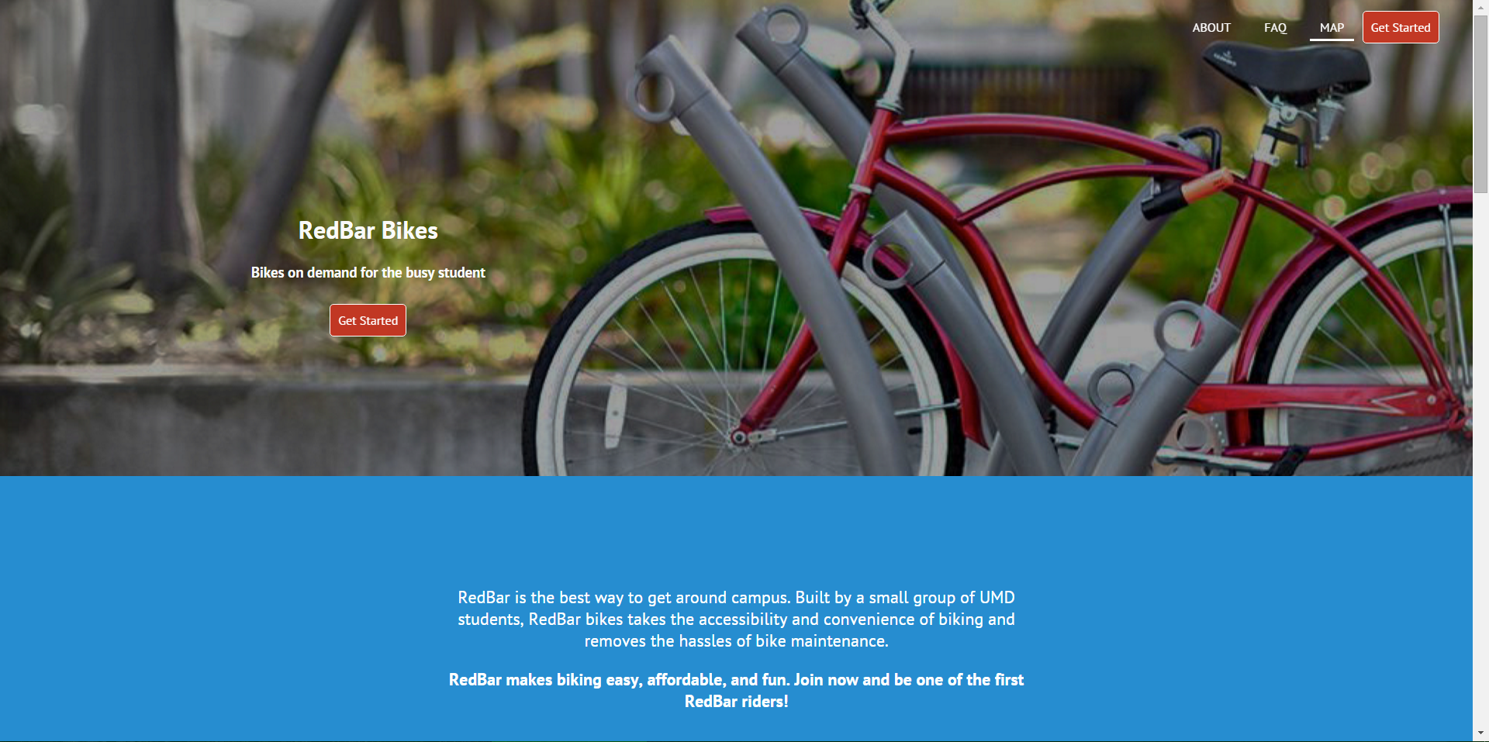

redbarbikes.com, zoom = 150%:

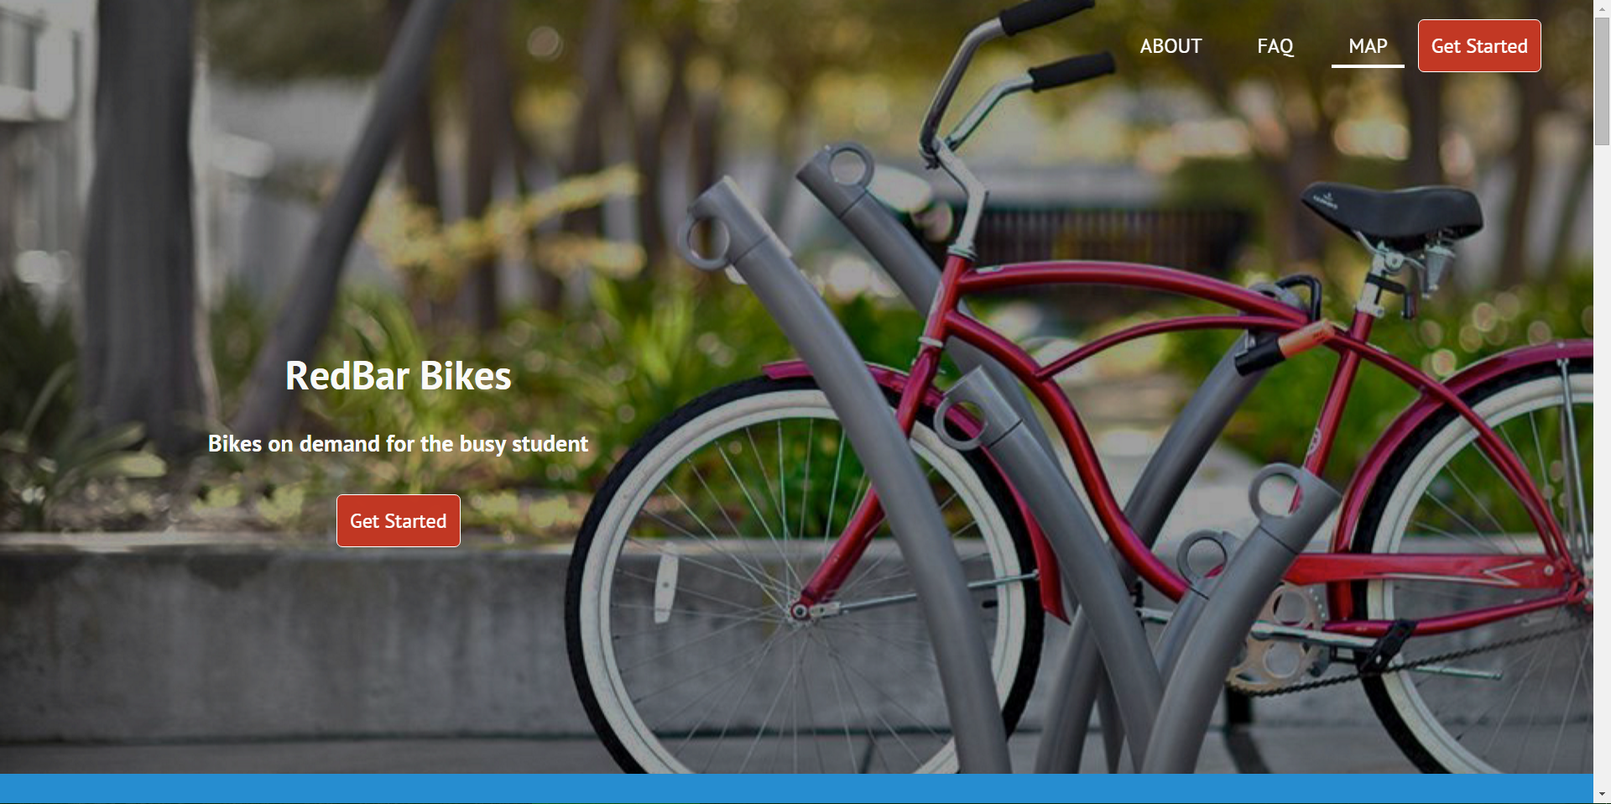

redbarbikes.com, zoom = 150% (cont.):

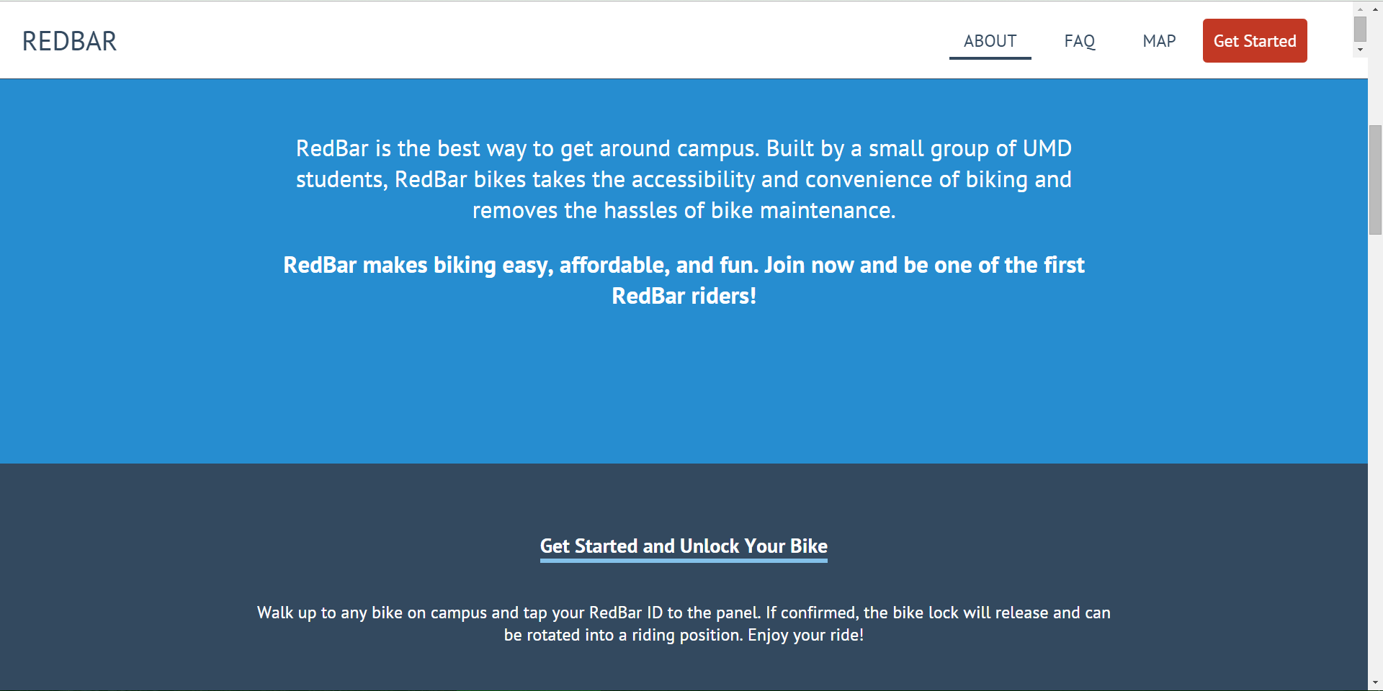

However, **the current size looks just right on mobile**. Great job on making the page beautifully scalable on mobile!

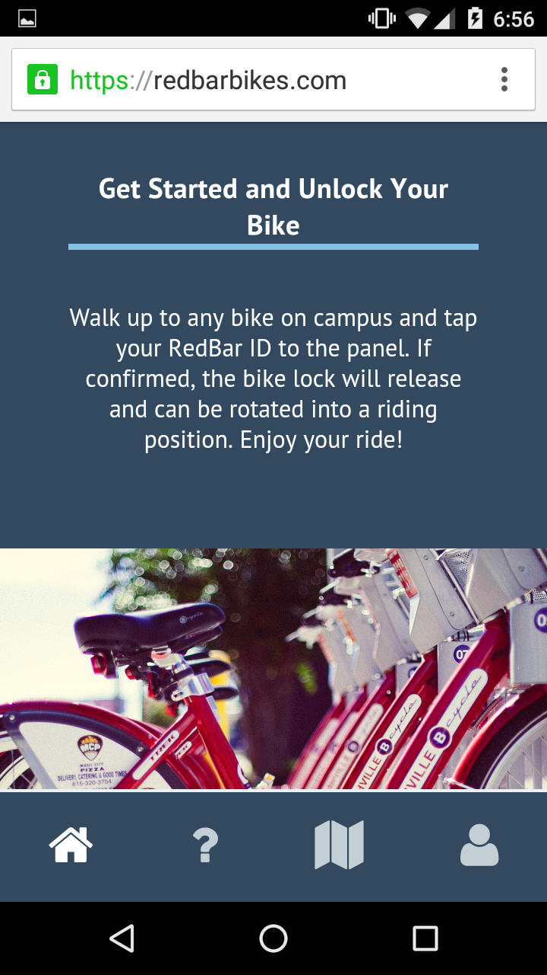 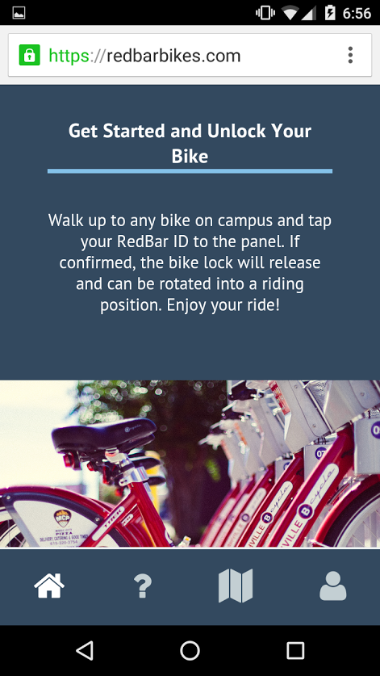

**2) Compress images** – Right now, the banner images on the page are several MB in size. While loading time would generally not be a problem with modern connections, it would incur sizeable data cost for those relying on mobile data. Assuming a good number of users would be visiting the page on mobile, and the fact that *umd-secure* is simply unreliable outdoors, it is worthwhile to consider compressing the images used throughout the page to make sure our users won’t be shocked when they check the data usage.

**3) Visual bugs**

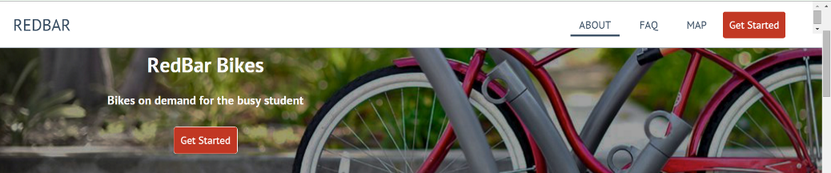**a. Mysterious inner scroll bar spotted!**

**b. Menu bar when scrolling down from the top of the page** – When the page is scrolled down by less than ~50 px, the menu bar appears to be conflicting with the banner image. This is not an issue when I use my mouse’s scroll, as it simply “skips” through the page in ~100px intervals. (I’m BSing these pixel numbers, by the way…); however, this is an issue when I smooth-scroll through the page using my touchpad.

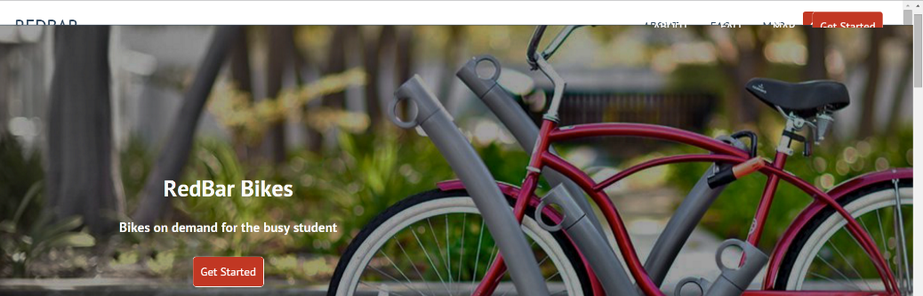

**4)** **(Down the road) Visualize the unlock/ride/return steps** – I think you did a great job making the instructions clear and concise; however, concepts like “rotate into a riding position” and “loop the lock through the hoop” can be ambiguous for those new to the system. We can eventually make simple animations to clarify these steps for new users. The easy way to do this (as far as I’m aware) is to build animations in PowerPoint and then save them as .wmv or other media format. Have you explored embedding a video to the page? I can certainly help with the animation building, once we have the prototypes ready.

Overall the page looks great! Let me know when you’re comfortable showing this to Kenneth. I’m sure he would be able to provide feedback on how to make the site more “professional.”